**Git & Github**

Depending on your version of Git, you may see some additional content there, but this is a fresh git init repository — it’s what you see by default. The description file is used only by the GitWeb program, so don’t worry about it. The config file contains your project-specific configuration options, and the info directory keeps a global exclude file for ignored patterns that you don’t want to track in a .gitignore file. The hooks directory contains your client- or server-side hook scripts, which are discussed in detail in Git Hooks.

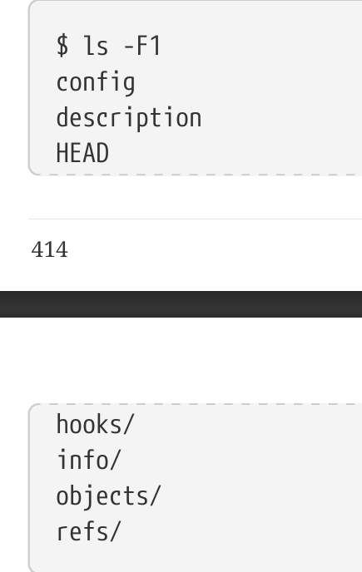

The objects directory stores all the content for your database, the refs directory stores pointers into commit objects in that data (branches, tags, remotes and more), the HEAD file points to the branch you currently have checked out, and the index file is where Git stores your staging area information. These are the core parts of Git.

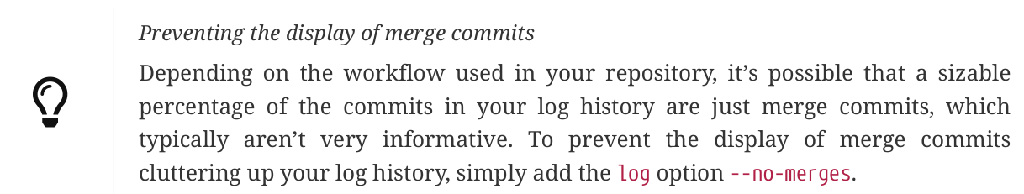

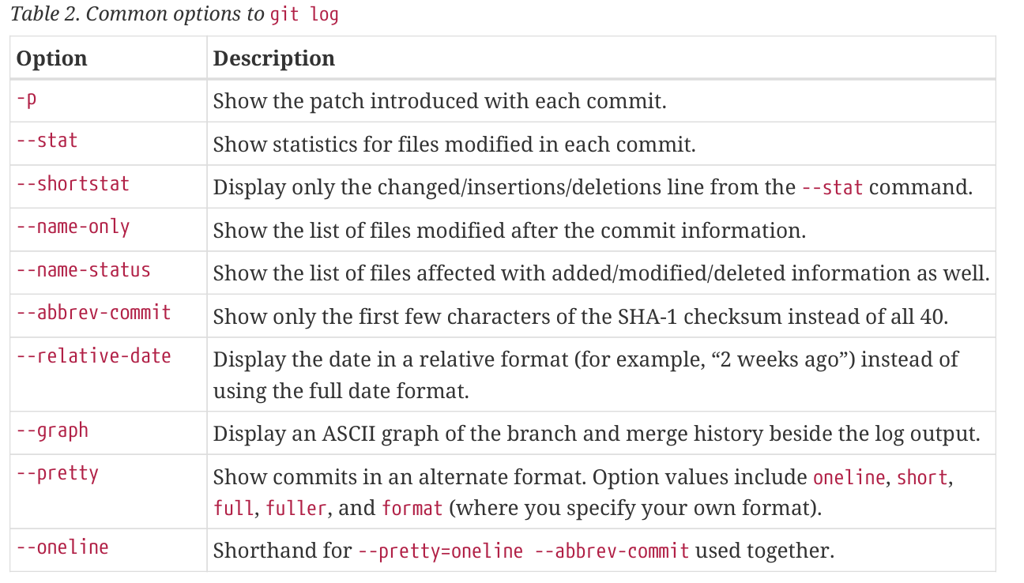

Paul’s master branch is now accessible locally as pb/master — you can merge it into one of your branches, or you can check out a local branch at that point if you want to inspect it.

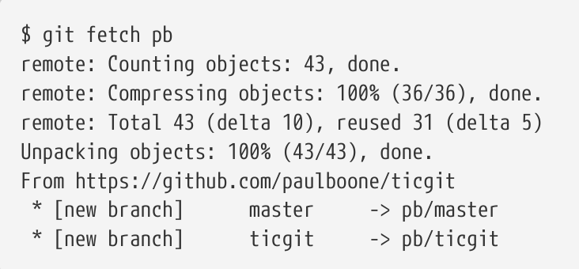

Running git pull generally fetches data from the server you originally cloned from and automatically tries to merge it into the code you’re currently working on.

By default, the git push command doesn’t transfer tags to remote servers. You will have to explicitly push tags to a shared server after you have created them. This process is just like sharing remote branches — you can run git push origin

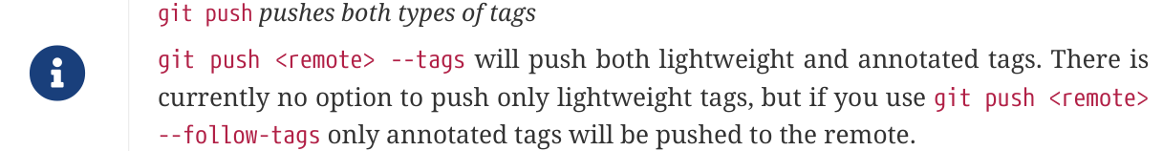

To view the versions of files a tag is pointing to, you can do a git checkout of that tag, although this puts your repository in “detached HEAD” state, which has some ill side effects